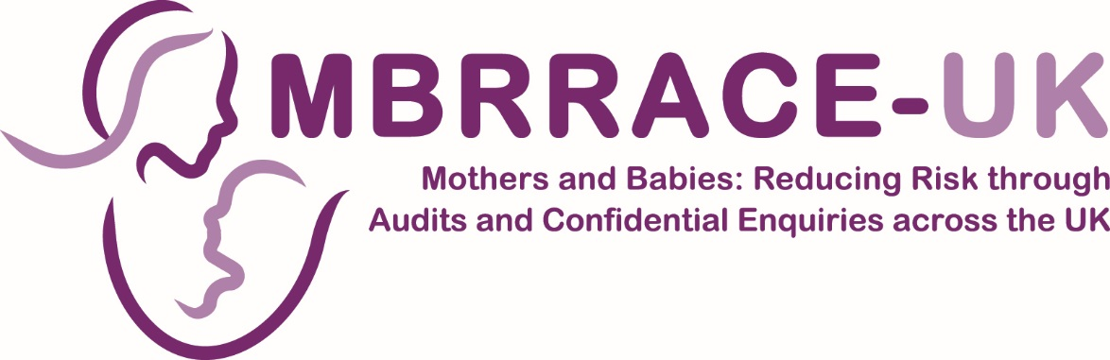
Saving Lives, Improving Mothers’ Care 2016 report launch
Friday 9th December
Royal College of Physicians and Surgeons of Glasgow
Coffee & Registration available from 9.00
Chair Jenny Kurinczuk
10.00 Welcome David Galloway
10.15 Maternal deaths 2012 – 2014 Marian Knight
10.35 Update from 2014/15 – 3Ps in a pod Rebecca Northridge

10.50 Cardiac disease – overall messages for care Bernard Clarke
11.20 SADS Esther Youd
11.35 Other cardiac disease Rachael James
12.00 Valve disease Sarah Vause
12.15 Standards for obstetric and cardiac care in Scotland Hazel Scott
12.30 Discussion
12.45 Lunch

Chair Marian Knight

13.45 Lessons for critical care Rupert Gauntlett
14.00 Early pregnancy care – key messages Jenny Kurinczuk
14.15 Lessons on hypertension in pregnancy Kate Harding
14.30 A near-miss: my story Kerry Thomson

14.50 Local reviews Sara Kenyon
15.10 Update from 2014/15 – NHS Education Scotland sepsis package Helene Marshall

15.30 Discussion
15.50 Universal lessons for care Jenny Kurinczuk
  - 16:00 Close

